<https://www.youtube.com/watch?v=2Ci_QxJ1kiE>

<https://www.mapr.com/blog/in-depth-look-hbase-architecture>

<https://www.tutorialspoint.com/hbase/hbase_architecture.htm>

<https://phoenix.apache.org/>

<http://phoenix.apache.org/Phoenix-in-15-minutes-or-less.html>

<https://www.mapr.com/blog/in-depth-look-hbase-architecture> - Nice Material

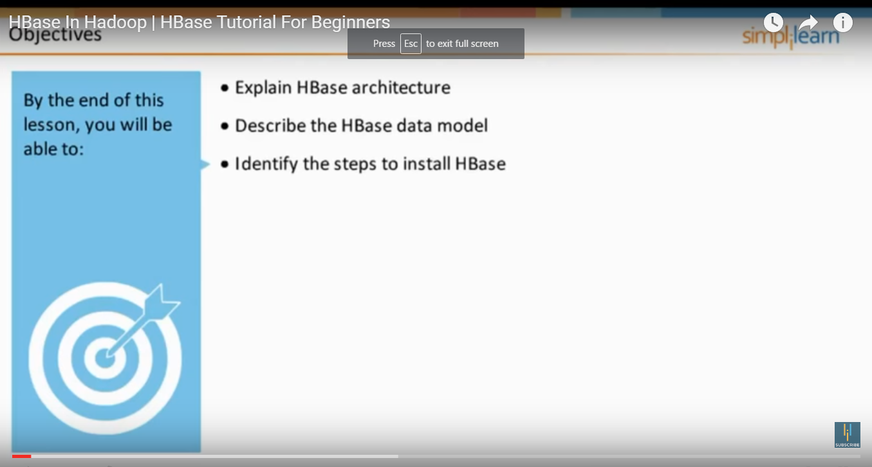

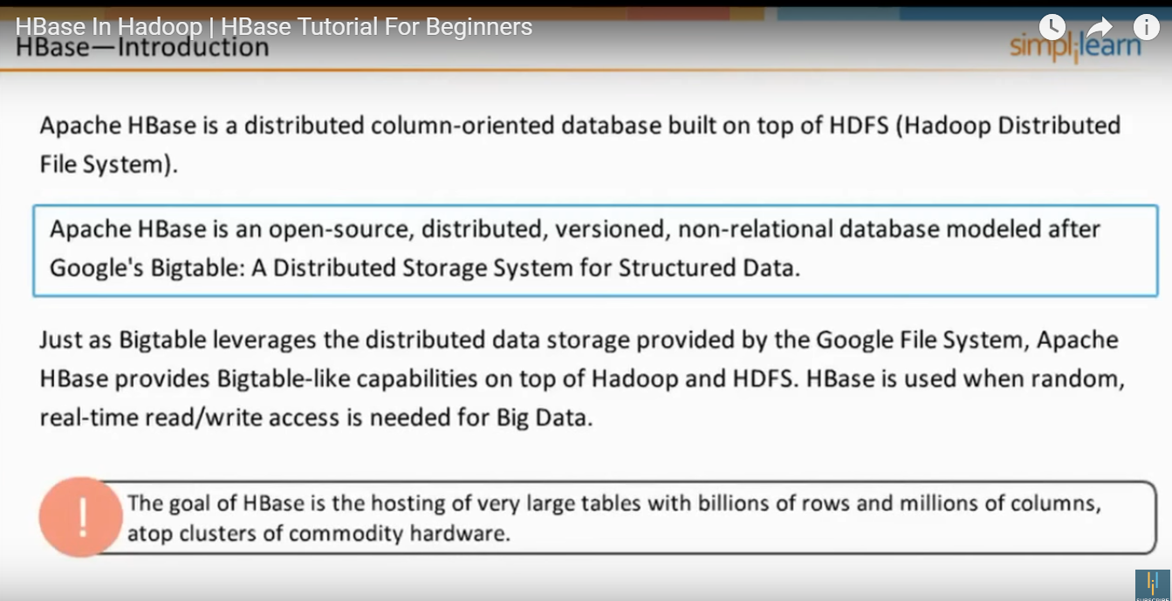

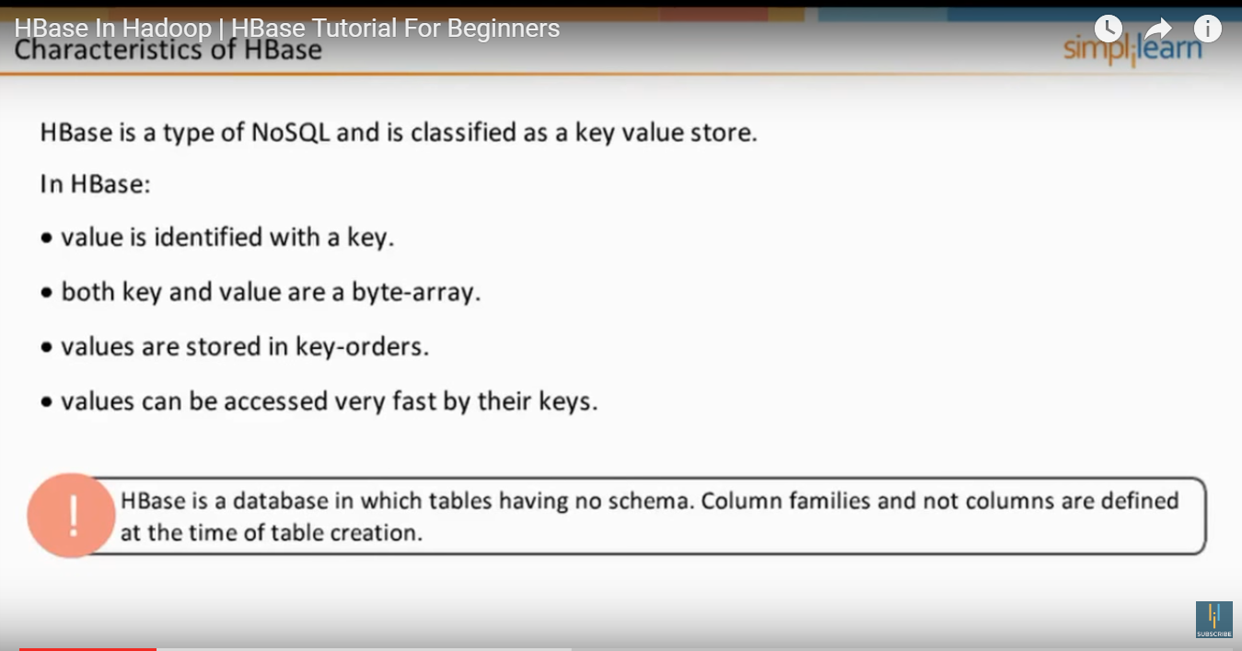

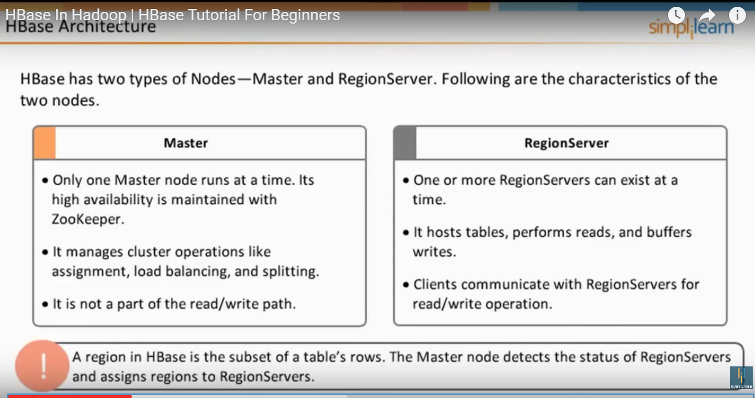

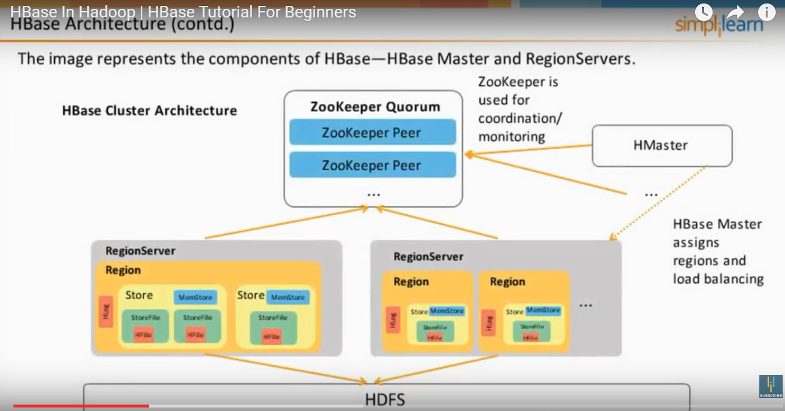

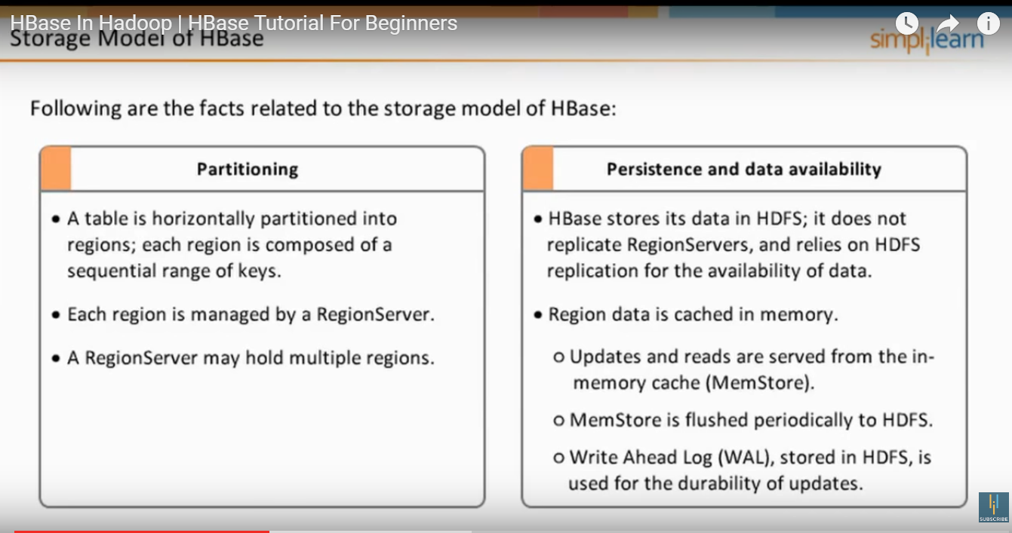

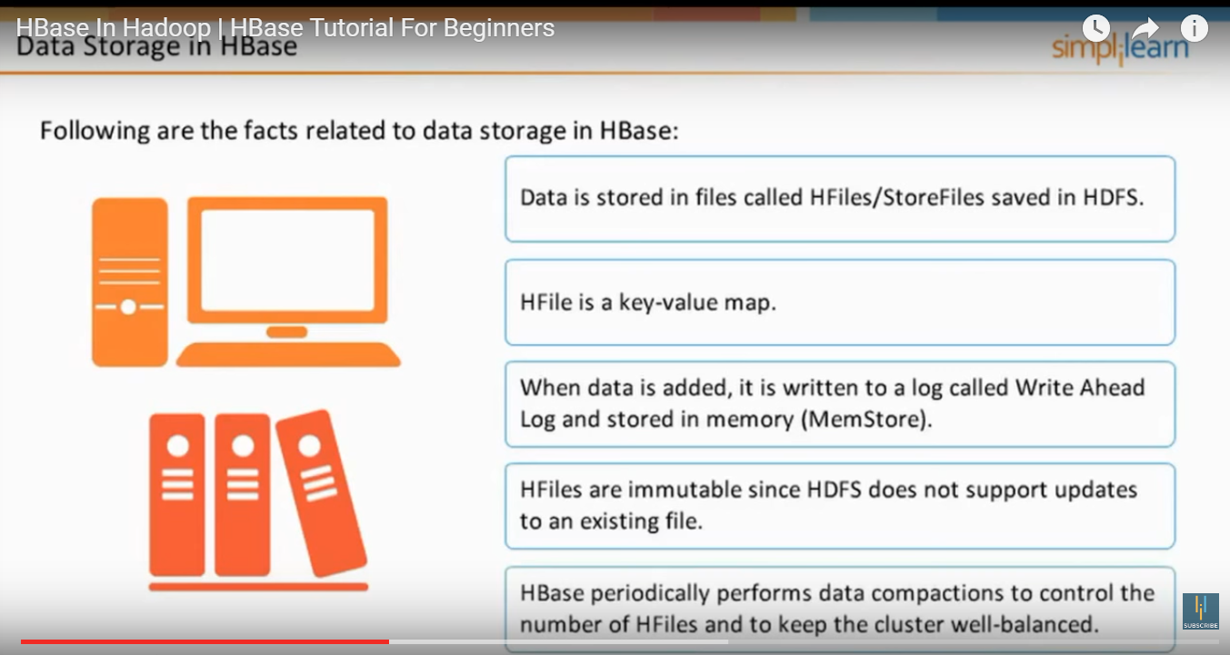

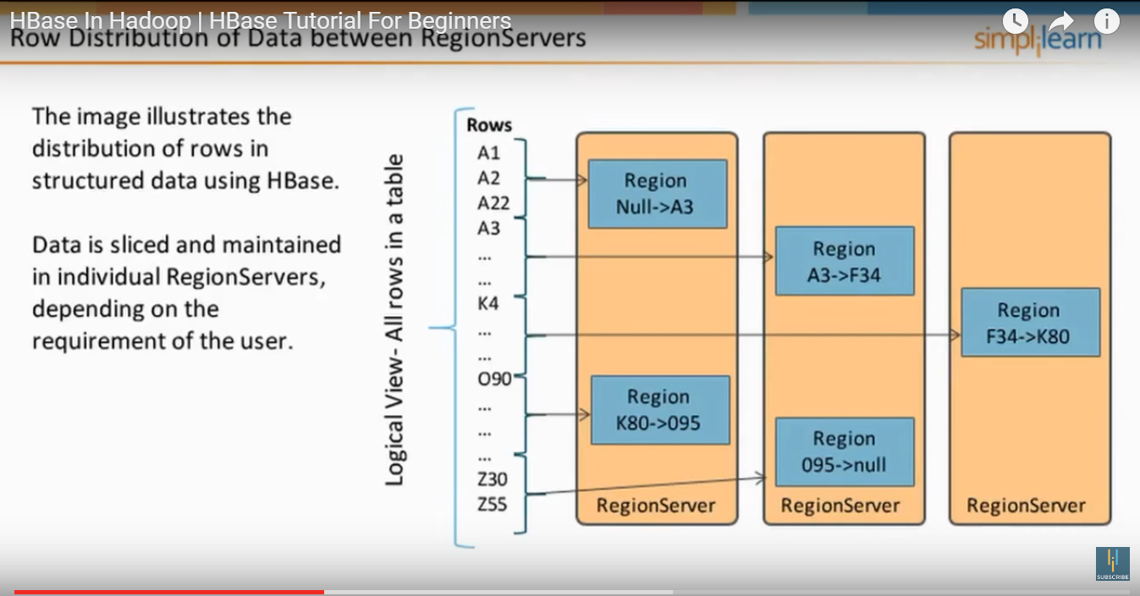

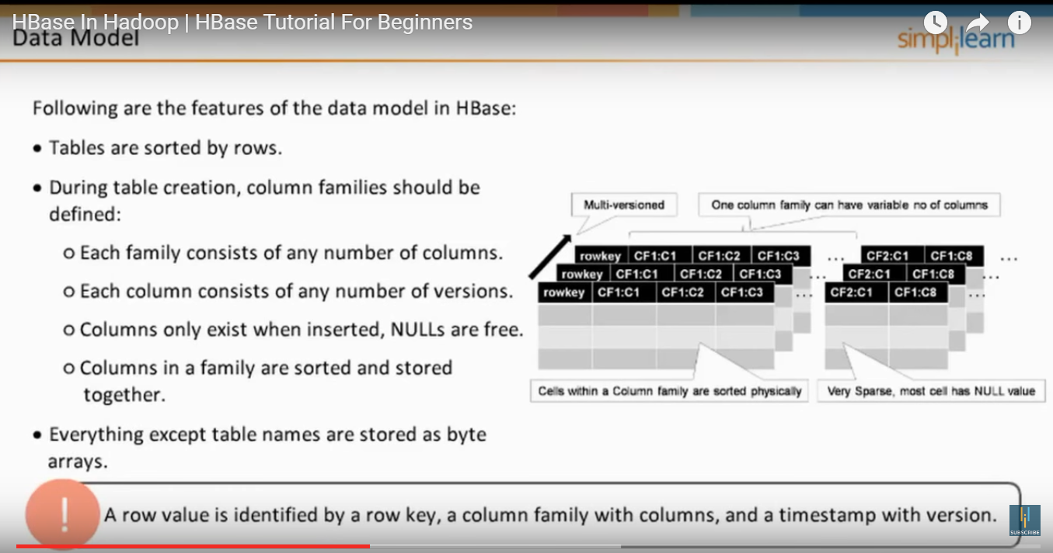

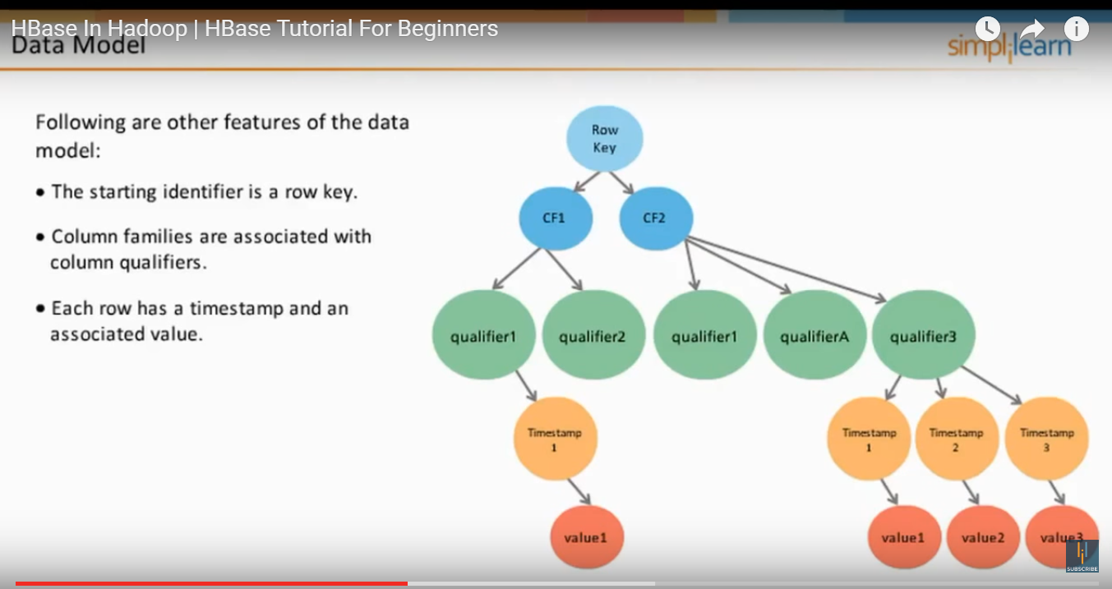

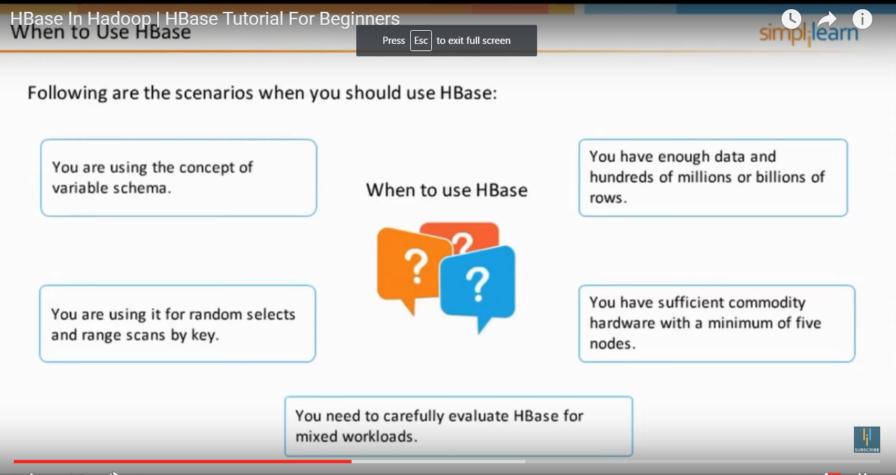

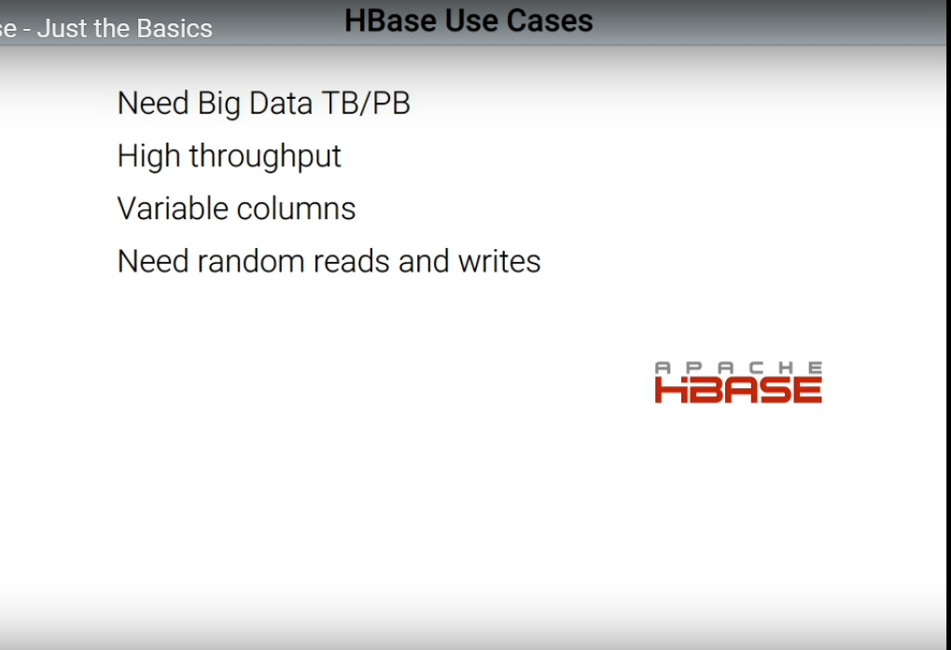

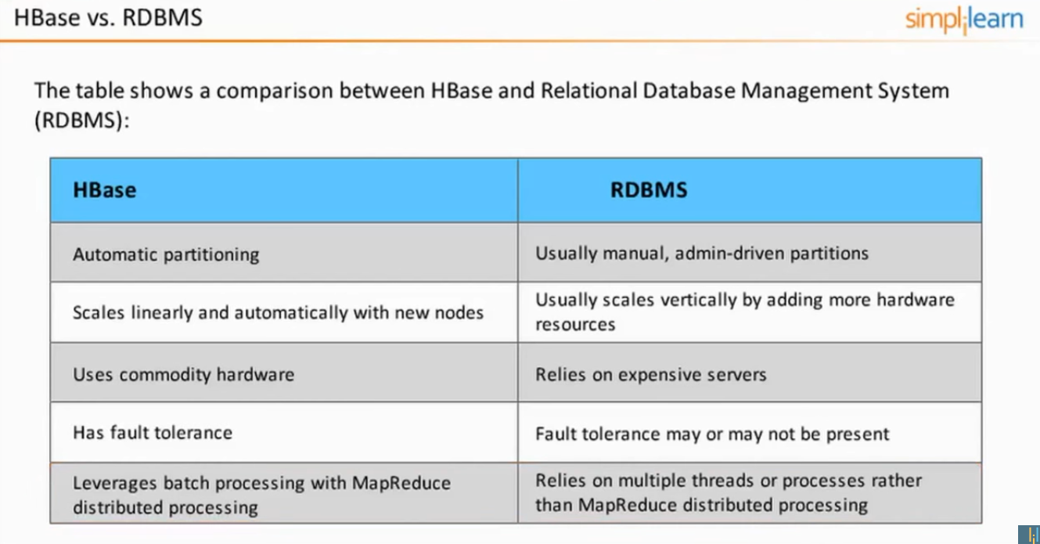

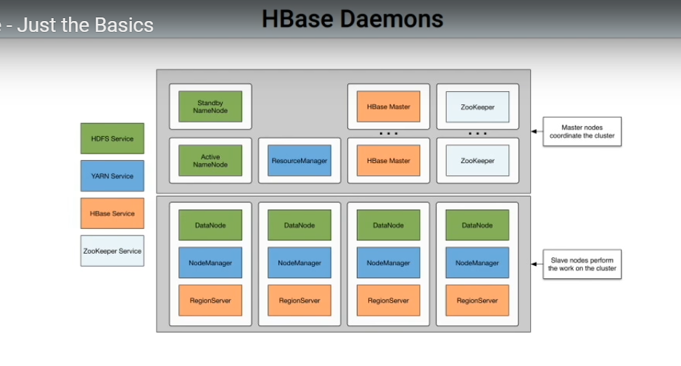

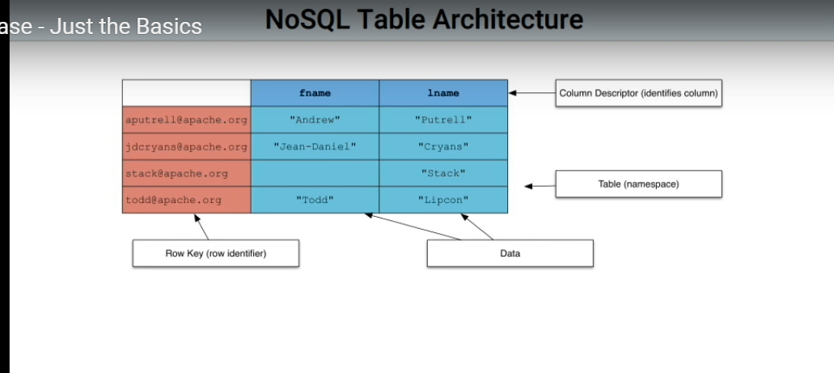

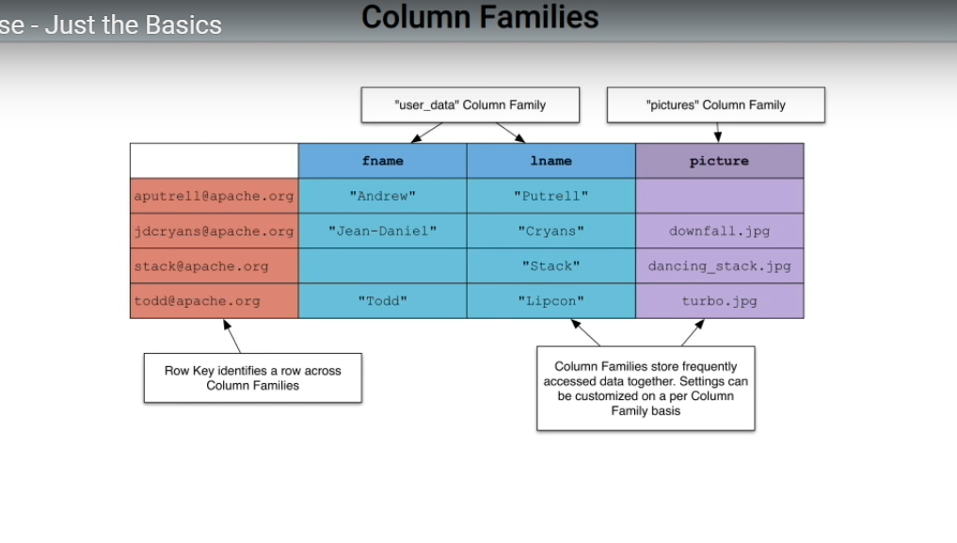

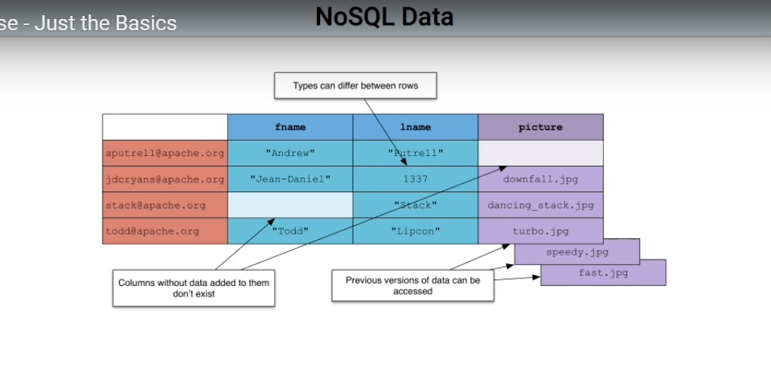

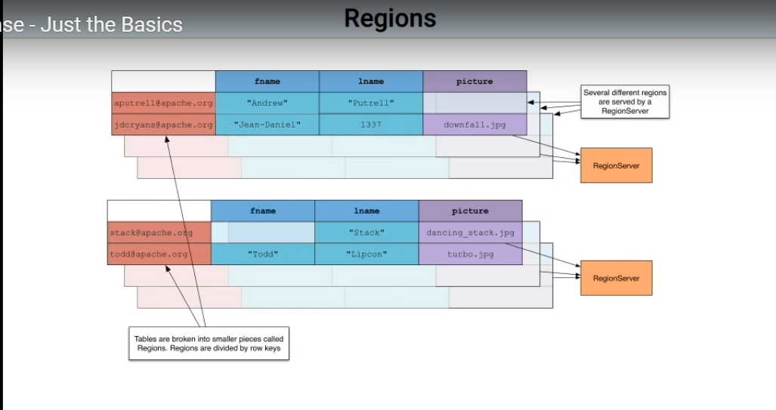

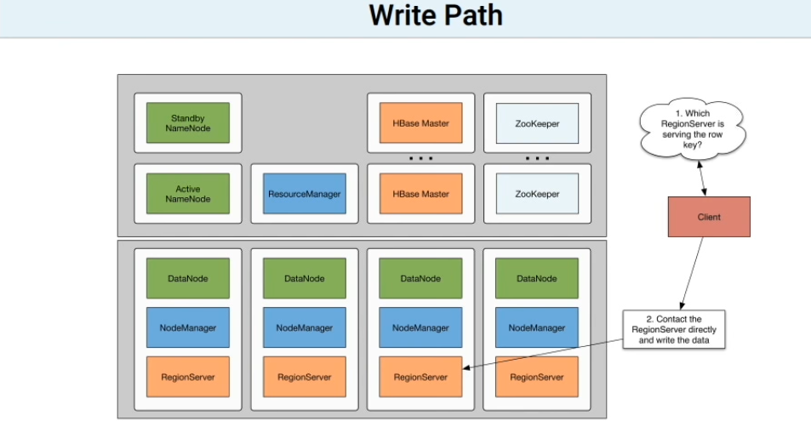

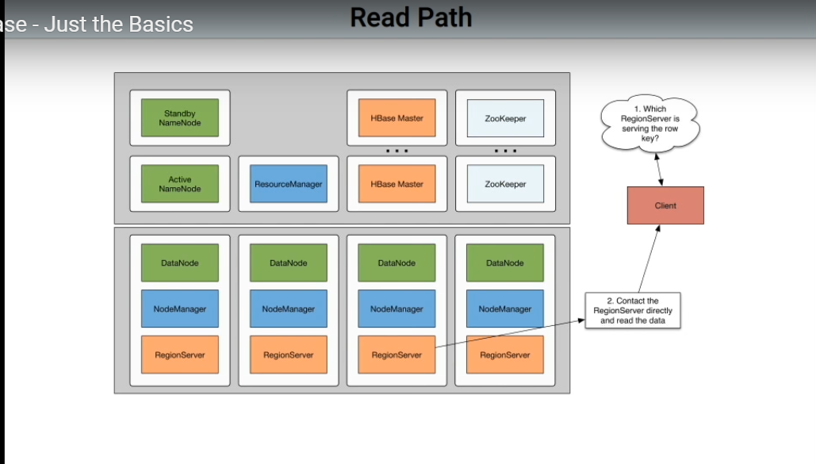

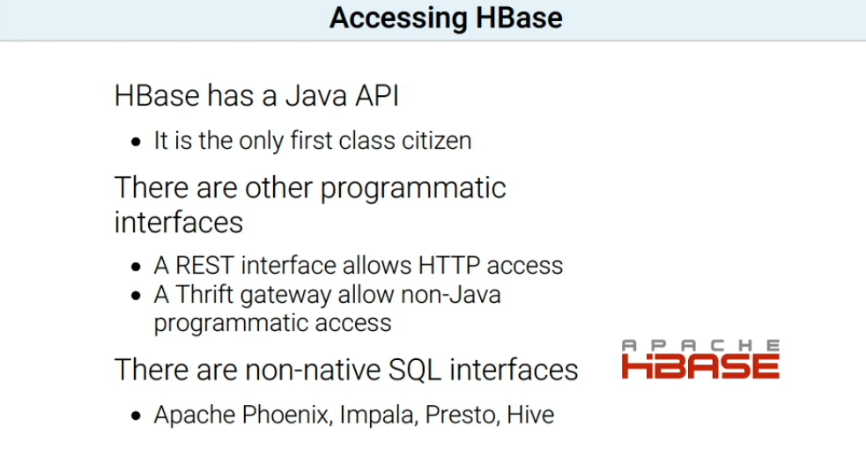

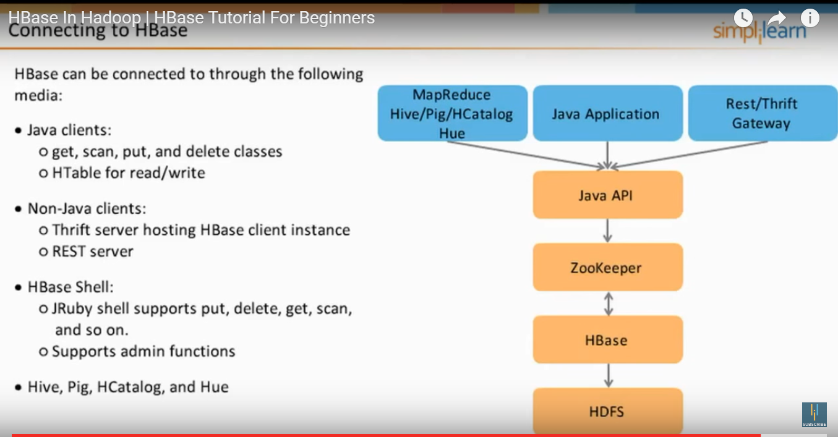

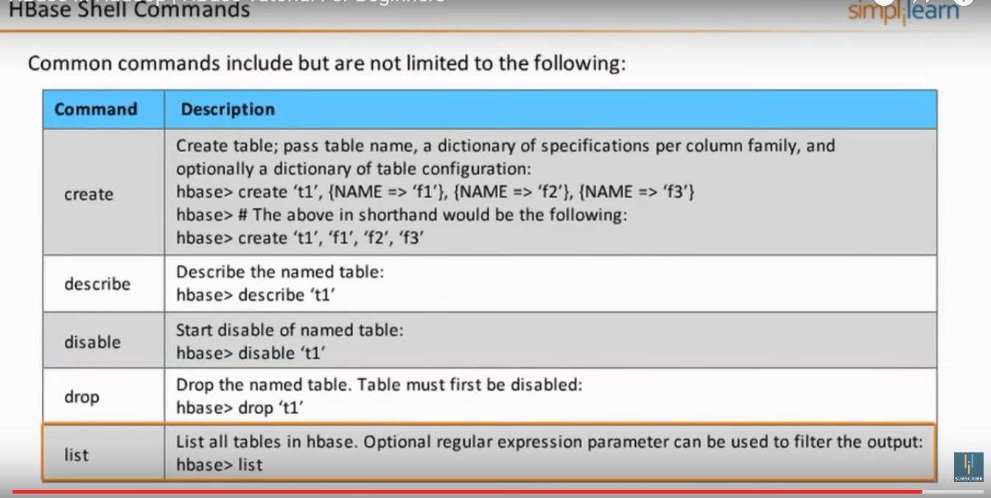

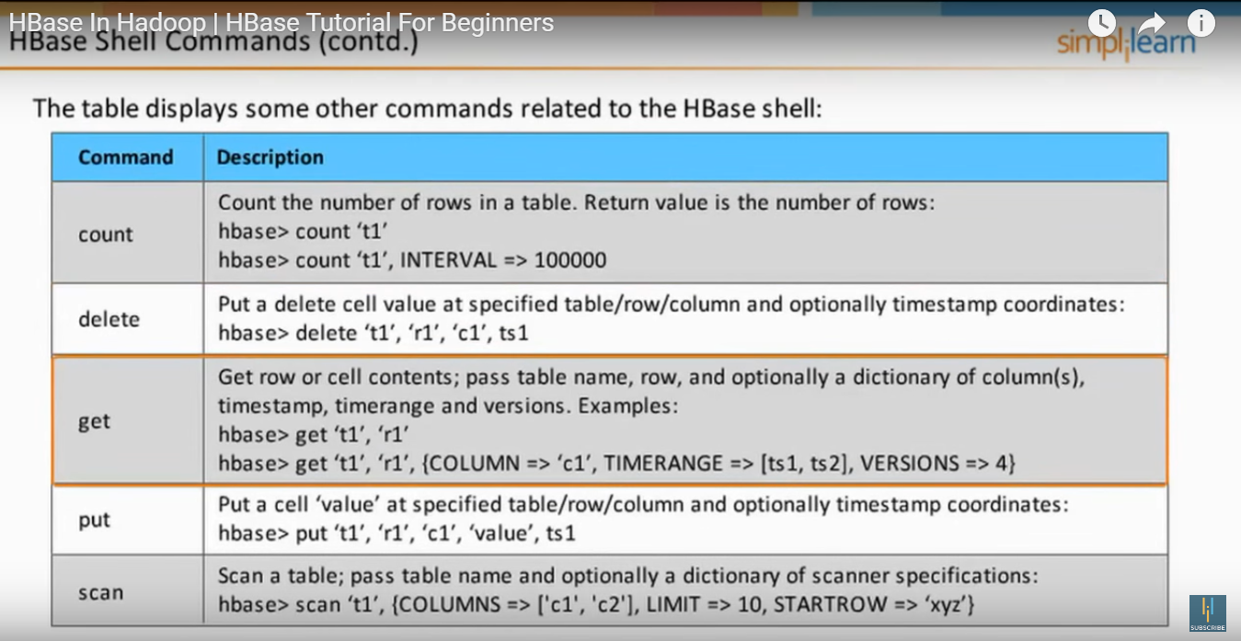

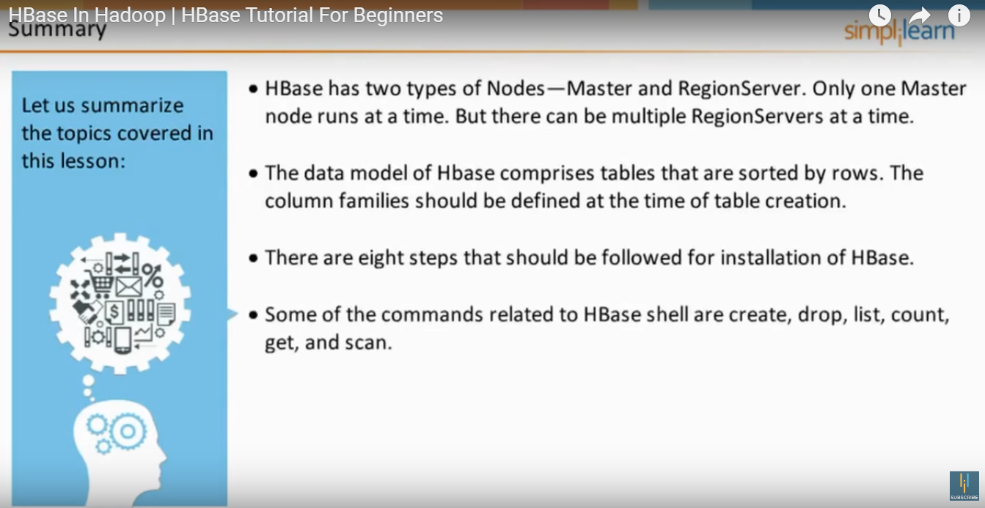

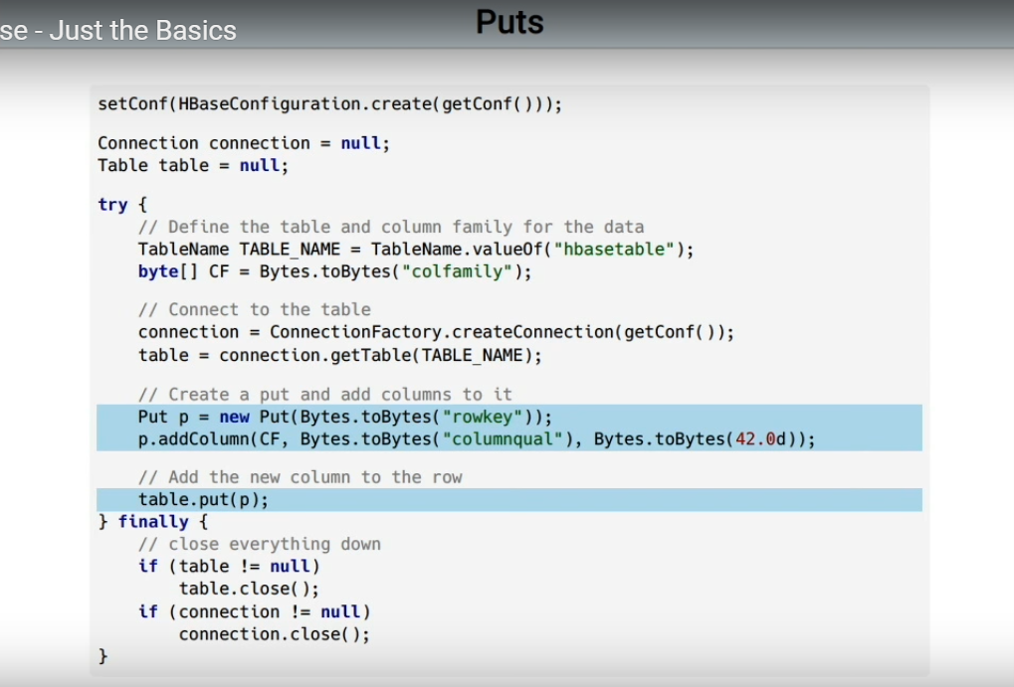

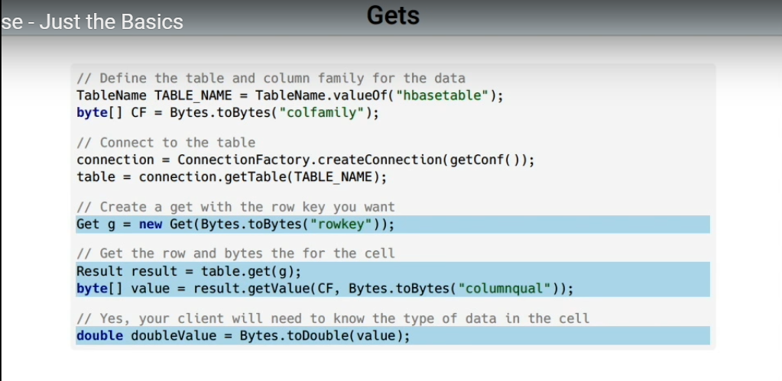

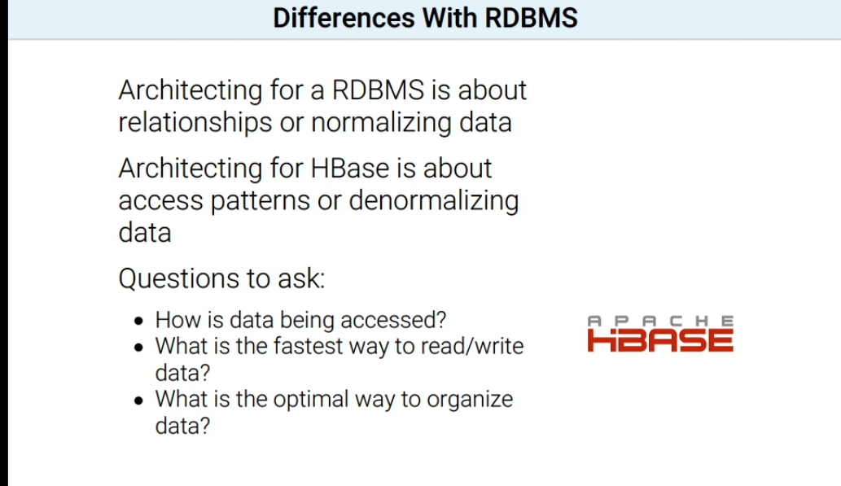



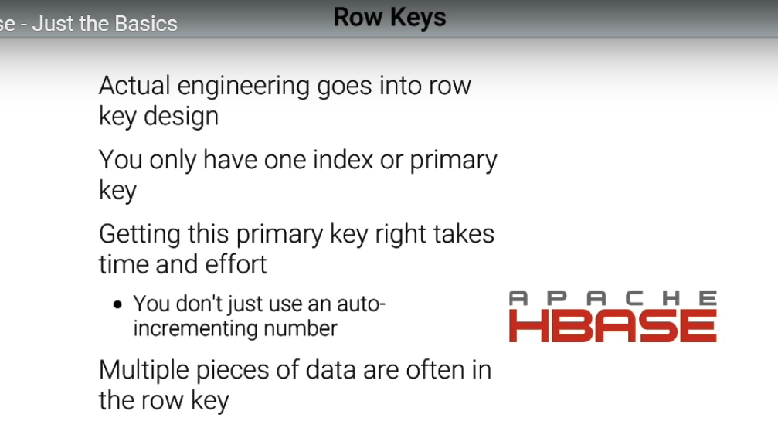

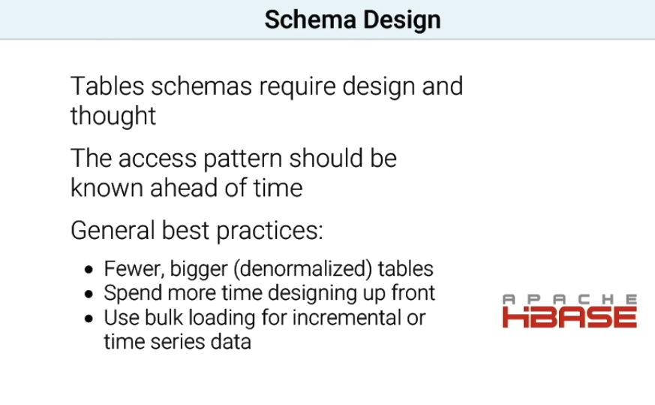

## HBASE Introduction

## http://www.netwoven.com/2013/10/hbase-overview-of-architecture-and-data-model/

[HBase](http://hbase.apache.org/) is a column-oriented database that’s an open-source implementation of Google’s [Big Table](http://research.google.com/archive/bigtable.html) storage architecture. It can manage structured and semi-structured data and has some built-in features such as scalability, versioning, compression and garbage collection. Since its uses write-ahead logging and distributed configuration, it can provide fault-tolerance and quick recovery from individual server failures. HBase built on top of Hadoop / HDFS and the data stored in HBase can be manipulated using Hadoop’s MapReduce capabilities.

Let’s now take a look at how HBase (a column-oriented database) is different from some other data structures and concepts that we are familiar with **Row-Oriented vs. Column-Oriented data stores.**As shown below, in a row-oriented data store, a row is a unit of data that is read or written together. In a column-oriented data store, the data in a column is stored together and hence quickly retrieved.

[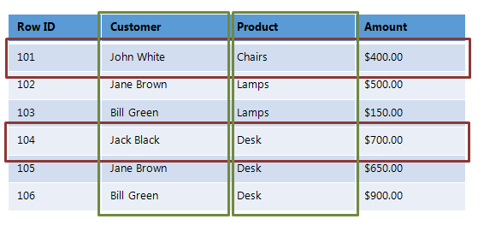](http://www.netwoven.com/wp-content/uploads/2013/10/hbase-12.png)

Row-oriented data stores –

* Data is stored and retrieved one row at a time and hence could read unnecessary data if only some of the data in a row is required.
* Easy to read and write records
* Well suited for OLTP systems
* Not efficient in performing operations applicable to the entire dataset and hence aggregation is an expensive operation
* Typical compression mechanisms provide less effective results than those on column-oriented data stores

Column-oriented data stores –

* Data is stored and retrieved in columns and hence can read only relevant data if only some data is required
* Read and Write are typically slower operations
* Well suited for OLAP systems
* Can efficiently perform operations applicable to the entire dataset and hence enables aggregation over many rows and columns
* Permits high compression rates due to few distinct values in columns

Introduction Relational Databases vs. HBase

When talking of data stores, we first think of Relational Databases with structured data storage and a sophisticated query engine. However, a Relational Database incurs a big penalty to improve performance as the data size increases. HBase, on the other hand, is designed from the ground up to provide scalability and partitioning to enable efficient data structure serialization, storage and retrieval. Broadly, the differences between a Relational Database and HBase are:

Relational Database –

* Is Based on a Fixed Schema
* Is a Row-oriented datastore
* Is designed to store Normalized Data
* Contains thin tables
* Has no built-in support for partitioning.

HBase –

* Is Schema-less
* Is a Column-oriented datastore
* Is designed to store Denormalized Data
* Contains wide and sparsely populated tables
* Supports Automatic Partitioning

HDFS vs. HBase

HDFS is a distributed file system that is well suited for storing large files. It’s designed to support batch processing of data but doesn’t provide fast individual record lookups. HBase is built on top of HDFS and is designed to provide access to single rows of data in large tables. Overall, the differences between HDFS and HBase are

HDFS –

* Is suited for High Latency operations batch processing
* Data is primarily accessed through MapReduce
* Is designed for batch processing and hence doesn’t have a concept of random reads/writes

HBase –

* Is built for Low Latency operations
* Provides access to single rows from billions of records
* Data is accessed through shell commands, Client APIs in Java, REST, Avro or Thrift

## From Hotonworks Site :

## http://hortonworks.com/hadoop-tutorial/introduction-apache-hbase-concepts-apache-phoenix-new-backup-restore-utility-hbase/

## 3DATA DEFINITION LANGUAGE COMMANDS IN HBASE

These are the commands that operate on tables in HBase.

### 3.1 CREATE

The syntax to create a table in HBase is create '<table_name>','<column_family_name>'. Let’s create a table called ‘**driver_dangerous_event’** with a column family of name **events**. Run the following command:

hbase> create 'driver_dangerous_event','events'

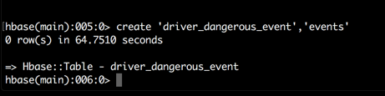

### 3.2 LIST

Let’s check the table we’ve just created, type the following command in the HBase shell

hbase> list

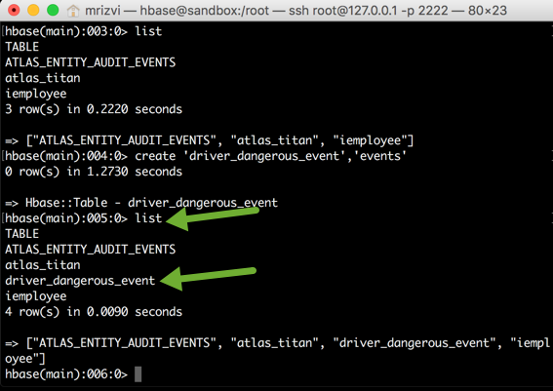

## 4. DATA MANIPULATION COMMANDS IN HBASE

Let’s import some data into the table. We’ll use a sample dataset that tracks driving record of a logistics company.

Open a new terminal and ssh into the Sandbox. Download the data.csv file and let’s copy the file in HDFS,

$>ssh root@127.0.0.1 -p 2222

$>curl -o ~/data.csv https://raw.githubusercontent.com/hortonworks/tutorials/hdp/assets/data.csv

$>hadoop fs -copyFromLocal ~/data.csv /tmp

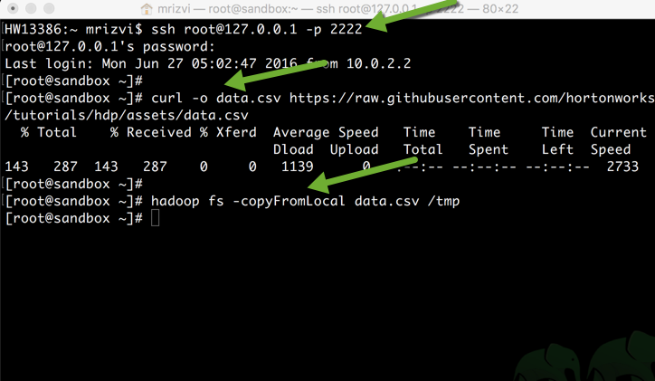

Now execute the LoadTsv from hbase user statement as following:

$>su hbase

$>hbase org.apache.hadoop.hbase.mapreduce.ImportTsv -Dimporttsv.separator=, -Dimporttsv.columns="HBASE_ROW_KEY,events:driverId,events:driverName,events:eventTime,events:eventType,events:latitudeColumn,events:longitudeColumn,events:routeId,events:routeName,events:truckId" driver_dangerous_event hdfs://sandbox.hortonworks.com:/tmp/data.csv

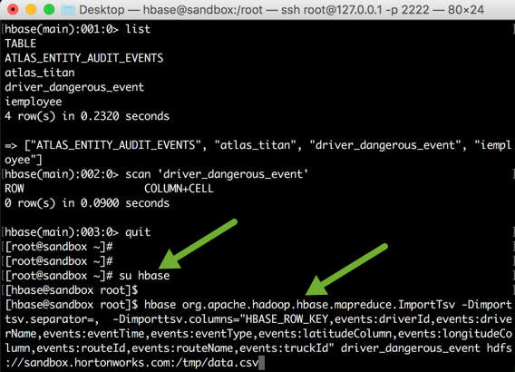

Now let’s check whether the data got imported in the table driver_dangerous_events or not. Go back to the hbase shell.

### 4.1 SCAN

The scan command is used to view the data in the HBase table. Type the following command:  
scan 'driver_dangerous_event'

You will see all the data present in the table with row keys and the different values for different columns in a column family.

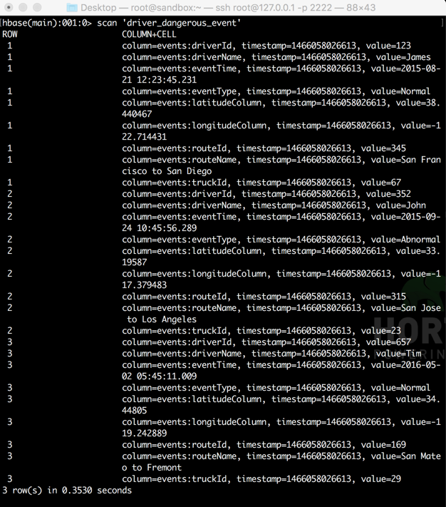

### 4.2 PUT

Using put command, you can insert rows in a HBase table. The syntax of put command is as follows:  
put '<table_name>','row1','<column_family:column_name>','value'

Copy following lines to put the data in the table.

put 'driver_dangerous_event','4','events:driverId','78'

put 'driver_dangerous_event','4','events:driverName','Carl'

put 'driver_dangerous_event','4','events:eventTime','2016-09-23 03:25:03.567'

put 'driver_dangerous_event','4','events:eventType','Normal'

put 'driver_dangerous_event','4','events:latitudeColumn','37.484938'

put 'driver_dangerous_event','4','events:longitudeColumn','-119.966284'

put 'driver_dangerous_event','4','events:routeId','845'

put 'driver_dangerous_event','4','events:routeName','Santa Clara to San Diego'

put 'driver_dangerous_event','4','events:truckId','637'

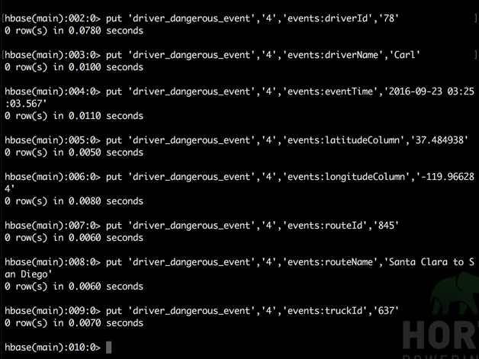

Now let’s view a data from scan command.

hbase>scan 'driver_dangerous_event'

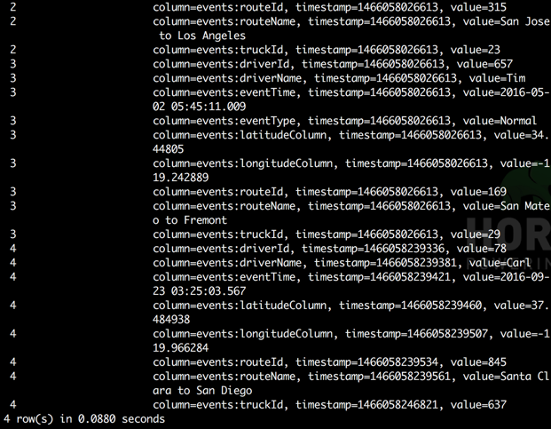

You can also update an existing cell value using the put command. The syntax for replacing is same as inserting a new value.

So let’s update a route name value of row key 4, from 'Santa Clara to San Diego' to 'Santa Clara to Los Angeles'. Type the following command in HBase shell:

hbase>put 'driver_dangerous_event','4','events:routeName','Santa Clara to Los Angeles'

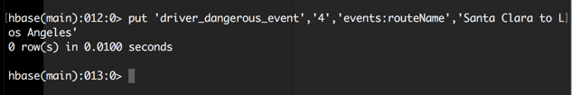

Now scan the table to see the updated data:

hbase>scan 'driver_dangerous_event'

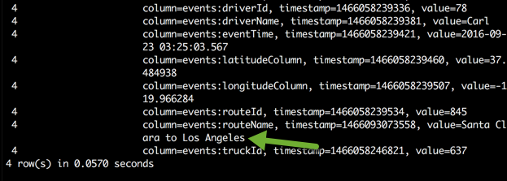

### 4.3 GET

It is used to read the data from HBase table. It gives a single row of data at a time. Syntax for get command is:  
get '<table_name>','<row_number>'

Try typing get 'driver_dangerous_event','1' in the shell. You will see the all the column families (in our case, there is only 1 column family) along with all the columns in the row.

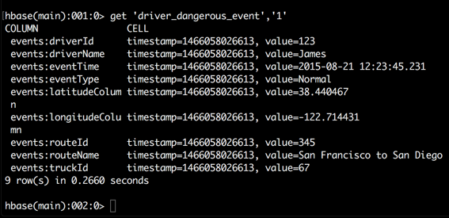

You can also read a specific column from get command. The syntax is as follows:  
get 'table_name', 'row_number', {COLUMN ⇒ 'column_family:column-name '}

Type the following statement to get the details from the row 1 and the driverName of column family events.

hbase>get 'driver_dangerous_event','1',{COLUMN => 'events:driverName'}

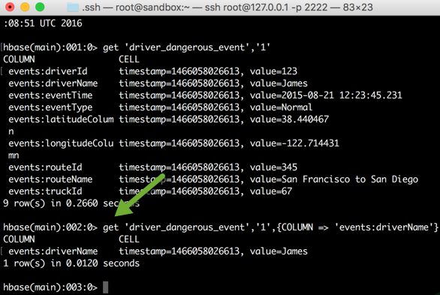

If you want to view the data from two columns, just add it to the {COLUMN =>…} section. Run the following command to get the details from row key 1 and the driverName and routeId of column family events:

hbase>get 'driver_dangerous_event','1',{COLUMNS => ['events:driverName','events:routeId']}

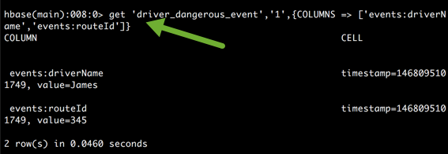

## 5. APPENDIX

**ImportTsv Utility in HBase:**

ImportTsv is a utility that will load data in TSV or CSV format into a specified HBase table. The column names of the TSV data must be specified using the -Dimporttsv.columns option. This option takes the form of comma-separated column names, where each column name is either a simple column family, or a columnfamily:qualifier. The special column name HBASE_ROW_KEY is used to designate that this column should be used as the row key for each imported record. You must specify exactly one column to be the row key, and you must specify a column name for every column that exists in the input data. In our case, events is a column family and driverId, driverName,etc are columns.

Next argument is the table name where you want the data to be imported  
Third argument specifies the input directory of CSV data.